System Design Document

Internship Project Name:

Front End - jQuery Vehicle Selector

Document Instructions:-

1. Text written in red fonts is instructions/information for corresponding sections.
2. Modify any sections as required and upload the updated document as artifact under specific task in WBS

<Use the table below to maintain information about the document and author. The author is usually the eIntern>

|  |  |
| --- | --- |
| Current Version: | <current version number> |
| Date Last Updated: | <last update date> |
| Last Updated By: | <update author name> |
| Author: | <author name> |
| Date Created: | <creation date> |

Revision History

<The table below can be used to maintain revision history and major changes done on each revision>

|  |  |  |  |
| --- | --- | --- | --- |
| Version Number | Date Updated | Revision Author | Summary of Major Changes Made |
|  |  |  |  |
|  |  |  |  |
|  |  |  |  |
|  |  |  |  |
|  |  |  |  |
|  |  |  |  |
|  |  |  |  |
|  |  |  |  |
|  |  |  |  |

Table of Contents

Contents

1 Document Overview 5

1.1 Scope 5

1.2 Related Documentation 5

1.3 Document Conventions 5

2 The Layered Web 6

3 Sequence Diagram 6

4 Activity Diagram 7

5 Page Wireframe 7

6 Implementation Specifications 8

# Document Overview

<This is a technical blueprint for the project.>

This document has been developed for the Carco jQuery Vehicle Selector Portal.

This document was developed from the Vehicle Selector Page Software requirement specification document and is intended to detail the

* The Layered Web
* Sequence Diagram
* Activity Diagram
* Page Wireframe
* Implementation Description

## Scope

<List summary of models and versions of servers and frameworks used to which this document relates.>

Languages and Framework: HTML5, XHTML, DHTML, CSS, JavaScript, jQuery

## Related Documentation

<List related documents to the internship project>

All documentation relating to the project can be found under project documents.

Other system documentation for this system should include:

System Requirement Specification

User Acceptance Test Cases

Work Breakdown Structure (Project Schedule)

## Document Conventions

<Describe what diagrammatic notation has been used in this document to represent the architectural views. Use of the Unified Modeling Language (UML) is strongly encouraged.>

All diagrams, charts, and tables are generated using standard UML guidelines.

# The Layered Web

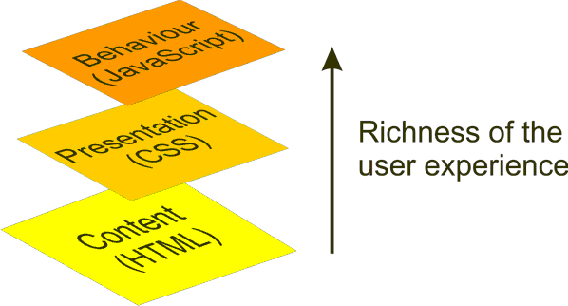

# Sequence Diagram

<The sequence diagram is used primarily to show the interactions between objects in the sequential order that those interactions occur.>

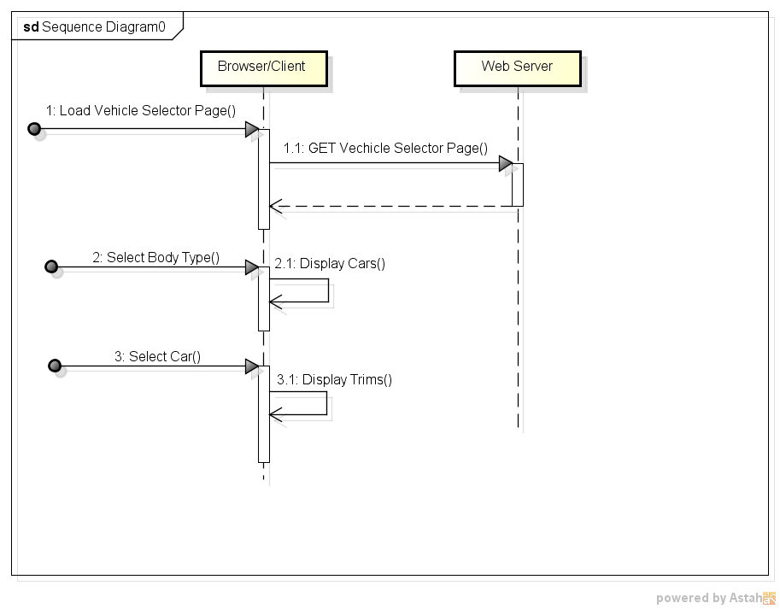

# Activity Diagram

<Activity diagrams are graphical representations of workflows of stepwise activities and actionswith support for choice, iteration and concurrency.>

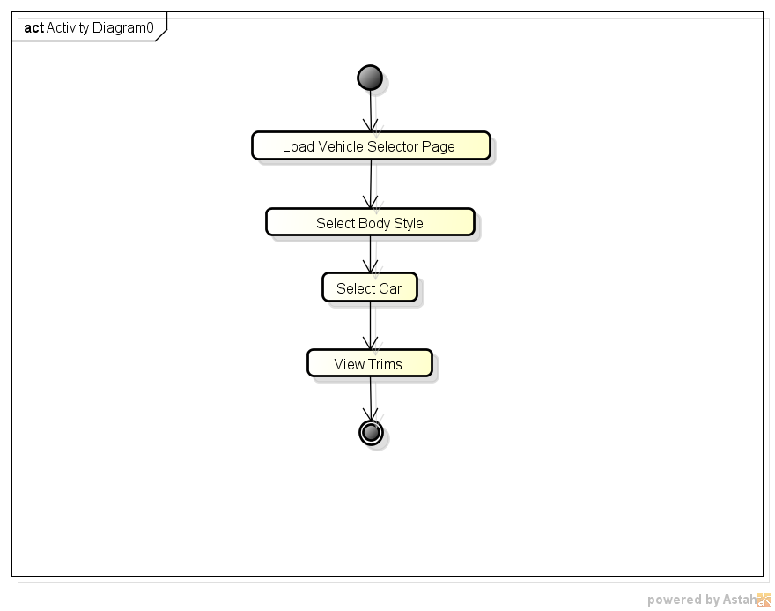

# Page Wireframe

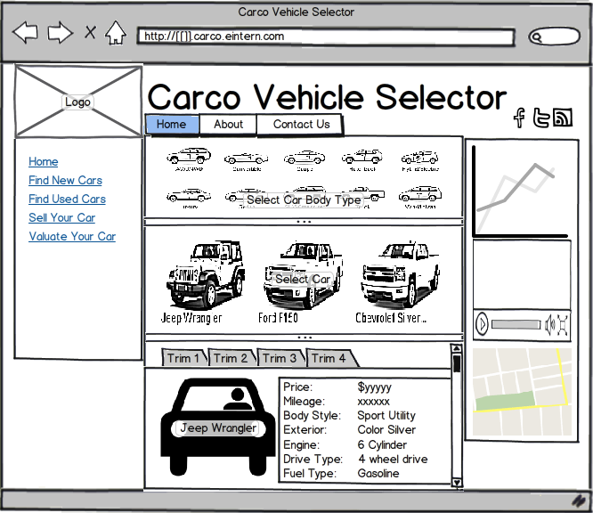

# Implementation Specifications

* + 1. HTML Content Specifications

The HTML content loaded by the page initially will display the Body Style Selector section listing the various body styles of cars available at the dealership.

The page will also have loaded all the car images into hidden DIV tags during initial page load.

When required, the JavaScript in the page will hide / show sections of the page as per user selections.

* + 1. CSS Layout Specifications

The layout specifications are described below:

1. Create a basic 3 column page layout for a site. The columns have the following width specification:

25% Left Column

50% Center Column

25% Right Column

1. The layout should consist of a Header, a Left Column, a main Content Section, a Right Column and a Footer.
2. The header should consist of a Logo, Site Title, Site Sub-Title and icon links to the company’s Twitter, Facebook pages and an RSS feed link. The icons need to be aligned to the right.
3. The navigation should consist of a Home, About, and Contact Us links horizontally aligned next to each other.
4. The footer should consist of a Copyright notice, a link to Privacy Terms and Contact Information.
   * 1. jQuery Behavior Specifications
5. Upon Loading, the browser will attempt to download jQuery from Google’s CDN. And a local fallback script will ensure that jQuery is loaded from the local server if loading from CDN has failed.
6. Using jQuery, the Body Style Selector links are linked unobtrusively to a click event handler on the parent element using jQuery On method for Event Bubbling.
7. When user clicks a Body Style, the event handler code will identify the selected Body Style, find the corresponding cars on the page which are in hidden Divs and display them using jQuery Effect functions.
8. The hidden Car Divs will have an event handler assigned on the parent for the click event handler. When user clicks on a car, the Car’s name is extracted and the corresponding Div ID containing the car details is mapped.
9. The mapped Div ID is displayed, which details the vehicle specs of all available trims.